LPF – Kiddies Club
Community Interest Company
Making learning meaningful and fun
Company No: 8645341
Mobile: 074 2686 8190

LPF KIDDIES CLUBS CHILD INDUCTION POLICY

When children first join LPF Kiddies Club Out Of School Club they will be allowed to settle in at their own pace.
We encourage parents or carers to visit the premises with their children shortly before they are due to start. This gives the children the opportunity to look around the Club and ask any questions. It also gives parents the opportunity to complete the necessary paperwork for registration with the Club if this has not yet been done.
If necessary, parents or carers may stay with their children during the first week to help them
settle in.

Induction for new children
- The new child will be introduced to all members of staff and informed about any other regular visitors to the club.
- The Club’s activities, rules and routines, such as snacks, signing in and signing out, will be explained.
- The child will be shown around the Club and told where they can and cannot go.
- The fire evacuation procedure and the locations of all fire exits will be explained.
- The child will be introduced to the other children at the Club
- Staff will keep a close eye on the new child and will ensure that they are happy, engaged and feel secure in the Club environment.

If a child seems to be taking an unusually long time to settle in, this will be discussed with their parents or carers to see what can be done to make the transition easier.

Signed: 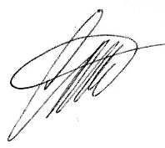 Date reviewed: 09/03/21
Director and Founder Carmel Britto

